
IS THAT FATHER CHRISTMAS?
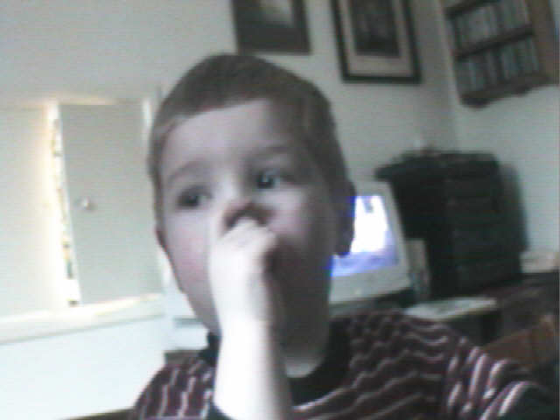
THIS IS CALLUM. IT IS CHRISTMAS EVE, AND HE IS DIEING TO STAY UP AND SEE FATHER CHRISTMAS THIS YEAR.



“Is that father Christmas mummy?” asked Callum.
Had the sleigh landed maybe, landed, on their roof?
“No” replied mummy shaking her head “That’s just daddy putting up the fairy-lights,”

“Oh” stammered Callum in a fainter voice.
“Well” he said in a regained voice “Is It that father Christmas?” Maybe it was Father Christmas coming down the chimney? “No that’s just our cat falling off the roof”

“Ohho” cried callum ”I wanna’ see Father Christmas.”

“Time for bed time” says dad picking callum up to putting him on his back and galloping upstairs
to his bedroom.
Callum was soon fast asleep when…….

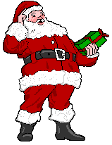

FATHER CHRISTMAS CAME!
He crept quietly into Callum’s bedroom and silently dropped a heap of presents into his stocking at the end of his wooden bed……
The next morning….. Callum woke up and peeped into his stocking then…”yehhhhhhhh!” he exploded, and his family friends or enemies could never un-stick him from the dreaded electric land!
Ahhhhhhhhhhhhhh!

