Fun In The Snow
28 January 2004

Chapter 1. The Day The Snow Was Dumped On Our World

I’ve never seen snow come down so fast. We were playing a game in the lounge, Jamie, Callum and Dad. I think the game was Junior Articulate, which Auntie Kate had given Jamie for his birthday a couple of weeks earlier.

At about half past four it looked like it was starting to rain. Then five minutes later we looked up from the game and we were amazed to see that the world was turning white.

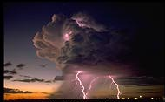Another five minutes went past and you
could no longer see the grass poking up
through the snow. And then the thunder
and lightning started. I’ve never seen a
snowstorm with thunder and lightning –
I thought that just happened in the
summer when it gets hotter and hotter
until something explodes.

At quarter to five we remembered that we had to pick up Ali from her choir practice in Cirencester. We thought we had better set off straight away otherwise there might be too much snow for us to get through.

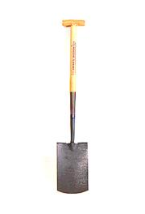
I’ve heard stories of people getting stuck overnight in their cars in the snow so we put a blanket, some extra fleeces and a spade in the car. The spade was in case the snow got so deep that we had to dig a way for the car to get through.

While I’d been doing this, Jamie and Callum had gone out onto the drive and were dancing about in the snow, throwing snowballs at each other.

They were having great fun, but we had to go. And we had to go quick otherwise the snow was going to be too deep.

I called them back in and we put on our coats and clambered into the car. I pressed the remote control to open the garage door and it made a kind of grrrooorrrnch noise, opened a tiny bit at the bottom and then wouldn’t budge. I realised that in just 15 minutes so much snow had fallen that it had blocked the garage door.

I ran out of the back door and kicked away the snow as fast as I could. I went back in and this time the garage door opened. Phew.

It was nearly dark as the car pulled out of the garage. The road was completely white and we slithered down through the village. We went out past the church and then we went very slowly down the steep bit to Brimpsfield Common.

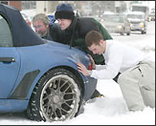There was a small van coming up the other way and it was so steep and slippy that two men were pushing it while a third man drove it. They just managed to get the van to the top of the steepest part and then its tyres got just enough grip through the snow to pull itself up the rest of the way.

The two men who were pushing, leaned on their knees breathing hard for a moment and then moved out of our way. We drove down through the tracks of the van, which snaked back and forth across the road. It looked like they had been pushing the van quite a long way. I thought that there was no way we would get back into Brimpsfield up this hill. No way.

We drove up to the dual carriageway to Cirencester and found loads of cars and lorries just standing there on the roundabout. Nothing was moving. I suppose the road was slippery in the dip by the Golden Heart pub where Ben works on Sundays. Whatever it was, nothing was moving to the left, but we needed to go right.

The trouble was there was big white van blocking our way round the roundabout. It was just sitting in front of us. I wound the window down and waved at them through the falling snow. However they were looking at the queue of cars in front of them and didn’t notice me waving at them.

I got out of the car and walked quickly over to the van with my shoulders hunched up to stop the snowflakes going down the back of my neck. I knocked on the side window of the van, and the man in the passenger seat jumped a little bit. I don’t think he was expecting someone to appear at his door in this weather.

He opened his window a little bit and I asked him to move backwards slightly so we could get through. He looked a little unsure because he didn’t know how much snow was behind him, but he said he’d do it.

As he reversed I scampered back to our car as quickly as I could and slammed the door shut. In just those few seconds I had got covered in snow. I brushed it off quickly so that it wouldn’t soak into my clothes.

The big van pulled back just enough for us to sneak through and we were able to set off up the dual carriageway.

On a dual carriageway there should be two lanes, but there was so much snow that one lane was completely covered and there were just two faint tracks on the inside lane. We set off slowly at first, but after a little while decided to speed up slightly. Still we were only going about 30 miles an hour on a road that we normally travelled at 80.
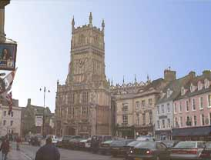
It was going to take a long time to get to Cirencester. I glanced over at the cars going the other way and groaned. It was going to take even longer to get back: there was a huge traffic jam on the other side.

← The church in the middle
of Cirencester

Eventually we got to Cirencester and only five minutes late. It was a good job we’d set off early. Ali and her friend Ffion jumped up excitedly when they saw us.

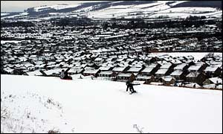

“It’s snowing! It’s snowing!” squealed Ali with delight. I tried to look excited as well, but inside I was a little worried that we might not be able to get back to Brimpsfield that night. I wondered if we might be sleeping in our car, stuck in a snowdrift somewhere, like those people I’d heard about.

I looked up at the dark sky. The snow was still falling, but it seemed a lot slower than before. Perhaps it was stopping.

Just in case we didn’t get home for ages, we went to McDonalds and bought some burgers. We scoffed them in the car and then I filled up with petrol and also bought a bag of drinks, crisps and sweets in case we needed more food that night.

We got back onto the dual carriageway heading back towards Brimpsfield and it took absolutely ages to get back. The snow had stopped falling now and I stopped worrying that we were going to be stuck in the car all night. But there was a huge traffic jam. We decided to eat some of the sweets and that helped a little bit.

At last we got Ffion back to her house at the bottom of Birdlip hill and we turned round to drive back to our house. Then we saw that a police car was sitting across the road with its blue lights flashing. They were stopping people from driving up Birdlip hill, because it was too slippery and dangerous.

We had to go the long way round past the Air Balloon pub, but at last we made it home. It had taken two and a half hours to fetch Ali from Cirencester. Normally it just takes half an hour.

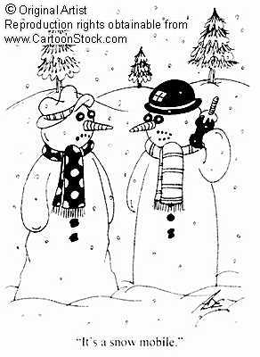

We were tired out, but not too tired to play in the snow on the drive. I got the sledges out and we pulled each other around in them.

Callum said, “I hope the snow is still here tomorrow.”

“Yeah,” replied Jamie, throwing some snow at him. “Maybe school will be closed.”

Chapter 2. The School Is Closed

We woke up the next morning and looked out of the window. The snow was still there!

“I hope the school is closed,” shouted Jamie, dancing around in a little circle.

“I don’t think it will be,” I replied, looking doubtfully out of the window. No more snow had fallen in the night and the road was looking almost clear because of the cars that had driven along it.

Just then the phone rang and Mum answered it. It was Mr Adams. Mum listened for a minute and then said: “The school is closed today. Apparently the bus can’t get along the icy roads.”

“SCHOOL’S CLOSED! SCHOOL’S CLOSED! SCHOOL’S CLOSED!” screamed Jamie to everybody else in the house. He put his hands up in the air and did another little dance. He ran up the hall and then back down the hall again. “SCHOOL’S CLOSED!” he shouted again in case they hadn’t heard him on the moon.

“Right then, let’s go sledging,” I said.

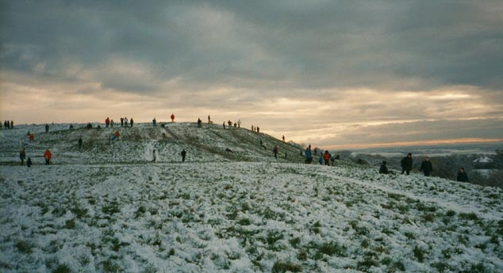

“WE’RE GOING SLEDGING!” screamed Jamie, running down the hall again.

While Jamie was running around the house shrieking, the rest of us got the box of skiing clothes out of the attic. We got out the salopettes and looked at them. We were all a bit bigger than last year and everybody had to wear the next size up.

Callum wore Jamie’s salopettes.

Jamie wore Ali’s salopettes.

Ali wore Mum’s salopettes. Then Mum decided that she was coming too and she wanted her salopettes back. Ali put Ben’s salopettes on instead.

Then we put on hats, scarves and gloves and got the three sledges out. We set off up the road with big smiles on our faces.

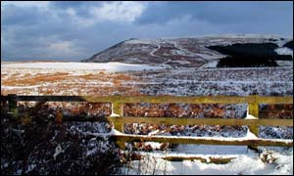

It was a beautiful sunny day with a blue sky. And it wasn’t that cold really.

As we went past Alexander’s house, we saw him outside with his Mum. She was scraping the snow off the car so that she could take Alexander to school.

We asked why she wanted to do a crazy thing like that and tried to persuade her to let Alexander have the day off as well. In the end she agreed and said that he could come sledging with us. Alexander jumped for joy and went to get his other clothes on.

I like to think that we rescued him from a day at school.

He came out wrapped up warm and we set off for the Humpy-Bumpy. We took it in turns pulling each other in the sledges across the first field.

Then we got to the Humpy-Bumpy and we jumped into the sledges and set off like rockets.

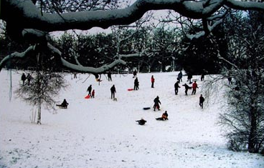

Jamie crashed straight away, but stood up covered in snow with a huge smile on his face. He jumped on again and set off once more.

Callum’s glove kept coming off for some reason, but he didn’t mind. In fact I think he thought it was funny.

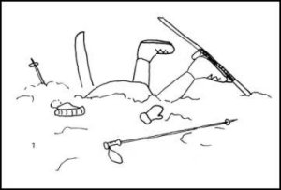
Alexander was completely mad. He kept going down the steep bank at the side, just so he would crash at the bottom.

We swapped sledges and went down again. Some people thought that Snow Fox was the fastest sledge, but I liked the old wooden sledge best.

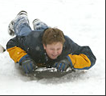
You could lie down on it and steer by dragging your feet at the back. And you went like an absolute rocket. Callum called this sledge Wooden Snow for some reason and made a label for it when we got home later.

Sometimes you went so fast down the Humpy-Bumpy that you couldn’t stop at the bottom. There was a barbed wire fence at the bottom under the trees and you had to dig your feet in really hard and then you still bumped into it.

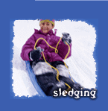
If you were brave – or just going to fast – you could throw yourself off the sledge just before hitting the fence. It didn’t hurt too much because the snow was quite soft.

We had a few races from the very top to the
very bottom. It was great flying down and
nobody seemed to mind walking up either.
I suppose everybody is a bit older now and
their legs are getting stronger.

For the last run, we made a convoy of all three sledges. They were tied together with their bits of black string. We went all the way from the gate at the top to the stile at the very bottom. I’ve never sledged so far in one go.

I was on Wooden Snow at the front with Callum. Alexander was on the middle sledge and Jamie was on the Snow Fox at the back.

It was funny because Jamie kept getting thrown out of the back sledge and we’d have to stop and wait for him. He laughed every time.

One time, Callum got thrown off the sledge and we couldn’t stop. He came running after us and grabbed hold of the back of the sledge. He couldn’t get in it though and he was dragged along on his tummy in the snow. We were all laughing so much I thought we were going to crash.

When the last run was finished we staggered back up to the gate at the top. In the next field I pulled Jamie, Callum and Alexander along in their sledges. We even did a loop-the-loop.

At the gate by the road, Farmer Partridge was burning all the bits of hedge that he’d cut down the previous week and there was a big cloud of smoke blowing across the path. Alexander shouted “Hold your breath as you go through the smoke cloud.”

I can still smell the smoke now as I think about it.

Alexander came back to our house to play. As we pulled the sledges onto the drive he said, “That was the best day of our lives.”

And do you know I think it was.

The End

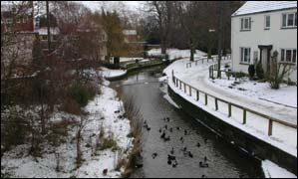

Ducks in the River Leven in the snowy town of Stokesley.

